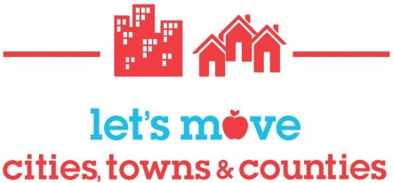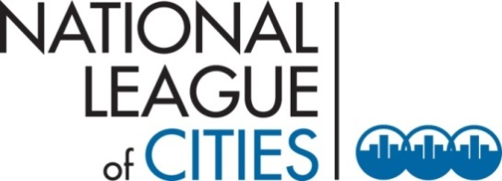

Let’s Move! Cities, Towns and Counties (LMCTC) All-Stars
Sign Up Form
Background:
Let’s Move! Cities, Towns and Counties (LMCTC) has seen incredible success over the past few years with over 30 cities and counties achieving gold medals in all five LMCTC goals. Many other participating communities anticipate reaching this designation in the next year.
Increasingly, communities involved in the initiative have expressed that they are interested in taking on more advanced and challenging activities as a next step after completing the five LMCTC goals. As a result, the National League of Cities (NLC) and the U.S. Department of Health and Human Services (HHS) have developed eight new strategies, called LMCTC All-Star Strategies. These strategies can be viewed at: www.HealthyCommunitiesHealthyFuture.org/all-stars
Only LMCTC sites that have reached gold in all five LMCTC goal areas are eligible to pursue these All-Star Strategies.
Purpose and Expectations:
The purpose of LMCTC All-Stars is to engage and support five gold medal cities and counties in pursuing more advanced, sustainable strategies to address childhood obesity. By signing up for LMCTC All-Stars, your city or county commits to:
- Designating a lead point person responsible for corresponding with NLC and HHS and acting as a peer resource to other cities and counties participating in LMCTC All-Stars.
- Selecting four of the eight strategies that will be pursued by your city or county, and within those four selected strategies, determining actions you will take that will be new work for your city or county. This information will be submitted using the “Strategies and Commitments Form”. When this form has been submitted, your city or county will be designated an All-Star Candidate.
- Taking new action in the areas identified. If an issue arises that impacts a city’s/county’s ability to carry out a specific action, discuss this with NLC, and alternative new actions may be agreed upon.
- Regularly updating NLC on your progress over time.

Support and Recognition:
NLC and HHS will work with the All-Star Candidate to identify technical assistance (TA) needs and desired timing and type of TA interactions. At a minimum, TA provided to All-Star Candidates will include quarterly or biannual calls and check-ins, peer learning opportunities, and consulting with subject matter experts. Once four of the eight commitments are completed, the LMCTC All-Star Candidate becomes an LMCTC All-Star.
More information is available at: www.HealthyCommunitiesHealthyFuture.org/all-stars

Sign Up Form

By completing the information below, the City/County of ____________________, agrees to the above expectations for LMCTC All-Stars.
Local elected official’s name:
Title:
Email address:
Phone number:

Lead contact’s name:
Title:
Email address:
Phone number:

If applicable, please list the contact information of other city/county staff or community partners who will serve as additional points of contact.
Additional contact’s name:
Title:
Email address:
Phone number:

Additional contact’s name:
Title:
Email address:
Phone number:

